DELHI PUBLIC SCHOOL RUBY PARK KOLKATA (700108)
PROJECT ON MICROBIAL FUEL CELLS AND SUSTAINABLE DEVELOPMENT A MOVEMENT TOWARDS SCIENCE, TECHNOLOGY, CREATIVITY AND WASTE MANAGEMENT

Introduction:-The need for sustainable and eco-friendly energy solutions is becoming increasingly critical due to the environmental impact of conventional energy sources. One promising solution is the use of microbial fuel cell (MFC) technology, particularly soil-based MFCs, to generate electricity on a large scale for residential use. Fossil fuels, which are the primary source of electricity, contribute significantly to greenhouse gas emissions and environmental pollution. Renewable energy sources such as solar and wind power, while effective in many ways, often face challenges related to setup expense, storage and management. It becomes thus increasingly important to introduce to the market an electricity generation method which is not just cost-friendly but also blends well with the Indian setting. The increasing global population leads to higher energy demands and more waste production Microbial Fuel Cells (MFCs) are an innovative technology that harnesses the natural metabolic processes of microbes to generate electricity. These devices can offer several environmental and practical benefits, making them a promising tool for sustainable energy production and waste management.

How Microbial Fuel Cells Work: MFCs consist of two main compartments: the anode and the cathode, separated by a proton-exchange membrane. Microorganisms, such as bacteria, are placed in the anode compartment, where they feed on organic matter (e.g., wastewater, sewage, or organic waste). As they metabolize the organic material, they release electrons and protons. The electrons are transferred to the anode and flow through an external circuit to the cathode, creating an electrical current. The protons pass through the membrane to the cathode, where they combine with oxygen to form water.

Materials used to make the model : -
- Sun board (made from waste paper)
- Arduino Uno
- LED (Light-emitting diode)
- Photoresistor
- Wire
- Thermocol (wasted thermocol sheets that are generally thrown away)
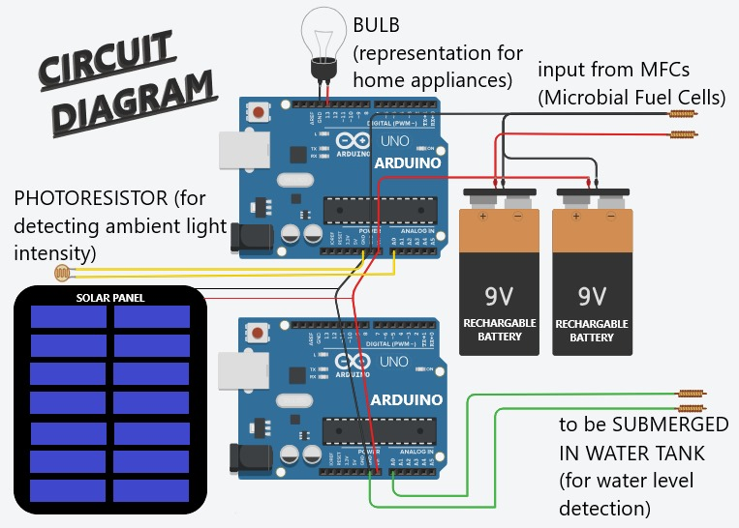
- General tools like pair of scissors, cutter, fevicol, hot glue gun, feviquick etc.
Working of the model

Energy from the MFCs or microbial fuel cells are used to power the house. the house in turn is very interesting. keeping in mind the developmental goals of a science project helping us find ways to look forwards towards the 17 sustainable developmental goals. Our project significantly affordability and clean energy, sustainable cities and community, climate action, infrastructure and innovation. We have tried to develop a miniature smart-home. This house has an existing feature that not only save electricity but also creates a marvelous ambience. Two Arduino mother boards can perfectly handle all the components with the greatest ease. The photoreceptor connected to one of the Arduino sense`s the amount of light of the atmosphere and then directs the lights inside the house to automatically change its brightness (brightness of the LED is inversely proportional to the amount of charge consumed.) and save electricity.

Benefits of Microbial Fuel Cells:
1. Sustainable Energy Production: - MFCs can generate electricity from organic waste, providing a renewable energy source that reduces reliance on fossil fuels. - The energy produced can be used to power small devices or even contribute to the electrical grid in larger-scale applications.
2.Wastewater Treatment: - MFCs can simultaneously treat wastewater while generating electricity. As microbes break down organic pollutants in the water, they help clean the water while producing energy. - This dual function makes MFCs particularly useful in locations lacking access to conventional wastewater treatment facilities.
3. Reduction of Greenhouse Gas Emissions: - By utilizing organic waste to produce energy, MFCs can reduce the release of methane, a potent greenhouse gas typically emitted by decomposing organic matter in landfills. - This contributes to mitigating climate change by lowering overall greenhouse gas emissions.
4. Applications in Remote and Off-Grid Locations: - MFCs can be deployed in remote or off-grid areas to provide a local, sustainable power source where traditional energy infrastructure may be unavailable. - They could be used to power sensors, monitoring devices, or small-scale equipment in remote locations.
5. Scalability and Versatility: - MFCs are scalable, meaning they can be designed for various applications, from powering small electronics to treating large volumes of wastewater in industrial settings. - They can also be integrated with other renewable energy technologies to enhance overall energy efficiency.
6. Environmental Monitoring: - MFCs can be used in environmental monitoring systems, as changes in the microbial community and activity can reflect the presence of pollutants or changes in environmental conditions.
To create a science model for MFCs, here are a few steps and tips you could follow:

Materials:
- Two chambers (plastic bottles, jars, or containers)
- Salt bridge (a tube filled with agar and salt)
- Electrodes (graphite rods or carbon cloth)
- Organic waste or soil containing bacteria (for the anode chamber)
- Oxygen (for the cathode chamber, usually air)
- Wires and a small LED or voltmeter

Steps:
- Build the Chambers:
  - One chamber will act as the anode (where the bacteria grow), and the other as the cathode (where oxygen is reduced).
  - Connect the chambers with a salt bridge to allow ion transfer while preventing oxygen from reaching the anode side.
- Prepare the Electrodes:
  - Insert the electrodes into both chambers. The anode chamber will contain the bacteria, while the cathode side will contain oxygen (you can leave this open to the air).
- Add Bacteria and Organic Matter:
  - Fill the anode chamber with mud, wastewater, or any material rich in microbes.
  - The bacteria will consume the organic matter and release electrons.
- Connect and Measure:
  - Use wires to connect the electrodes to a small LED or voltmeter. As bacteria produce electrons, the flow will generate electricity.
- Monitor the Output:
  - Once connected, you should see a small voltage produced, which you can measure or use to power a tiny LED.
Challenges and Future Prospects: -
Efficiency and Cost: Currently, MFCs produce lower power outputs compared to conventional energy sources, and the cost of materials and system maintenance can be high. Research is ongoing to improve their efficiency and reduce costs.
Scalability: While MFCs are promising for small-scale applications, scaling up the technology for widespread use remains a challenge. –
Material Durability: The materials used in MFCs, such as the electrodes and membranes, need to be durable and long-lasting to make the systems economically viable. In summary, microbial fuel cells offer a unique and sustainable approach to energy production, particularly in conjunction with waste management. As technology advances, MFCs have the potential to become a significant part of the renewable energy landscape, providing clean energy while addressing environmental challenges.

